Before you use GourmetPitt, you need to register an account. you can choose to register a customer or business account. At the register page , you need to enter your email address( you must enter in form of “XXXX@XX.com”) and passwords twice. If two passwords are not identical, an exception message will be toasted. After clicking “register” button, an e-mail will be sent to relative email address and user’s account information will be stored in database.

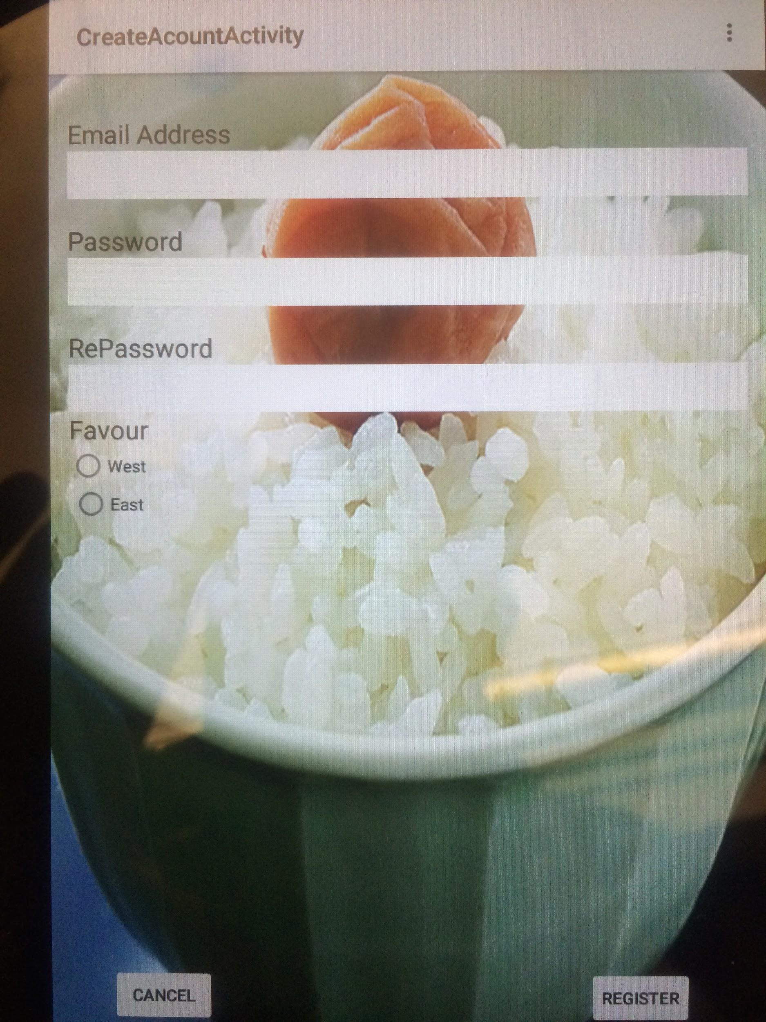

After registering himself/herself, the user can log in with the valid email address and password. The email address is case-insensitive and the password is case-sensitive. And the user must specify the user type, which is customer/business. The image below provides an example for logging in.

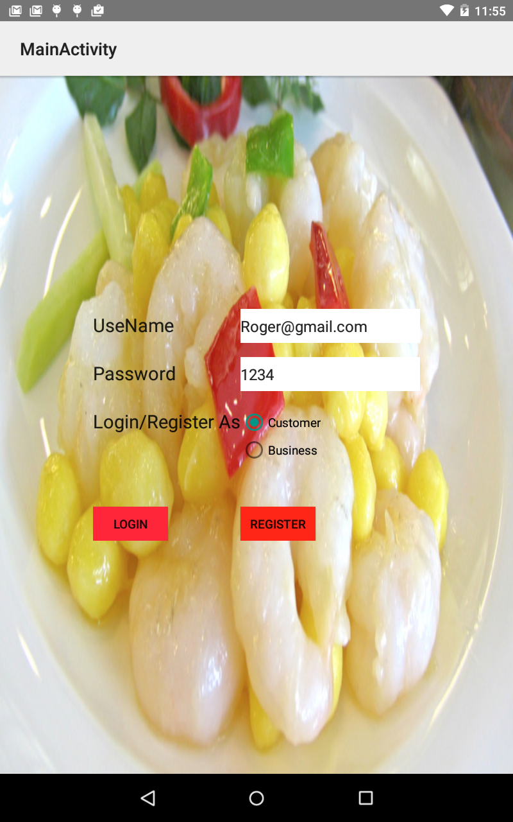

After logging in as a customer, a navigation drawer interface is presented.

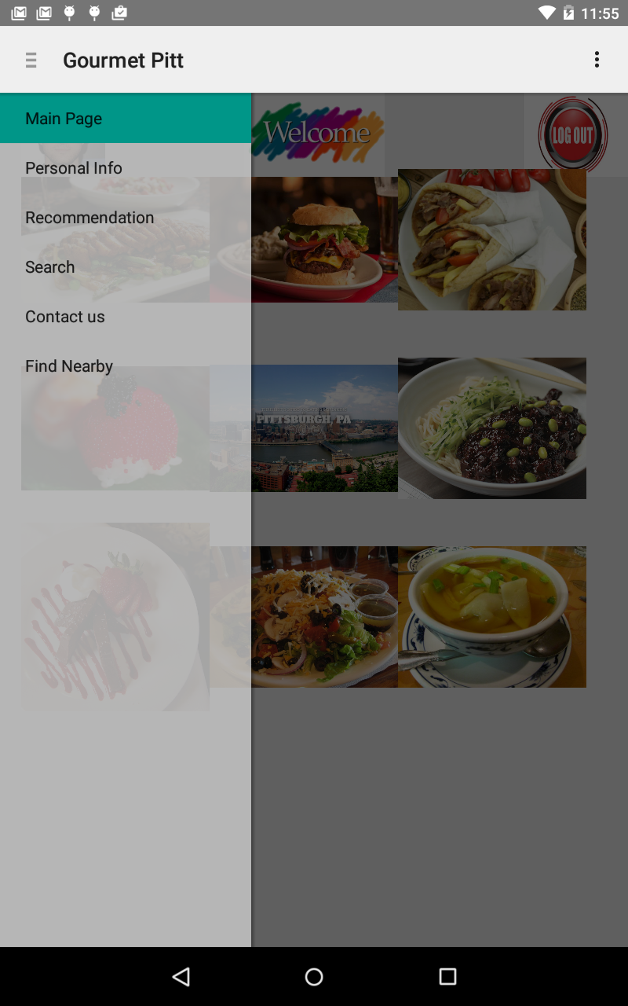

After you enter this app, the background music will keep playing in the background. You can use a BGMcontrol button at the customer home page to pause or restart the BGM.

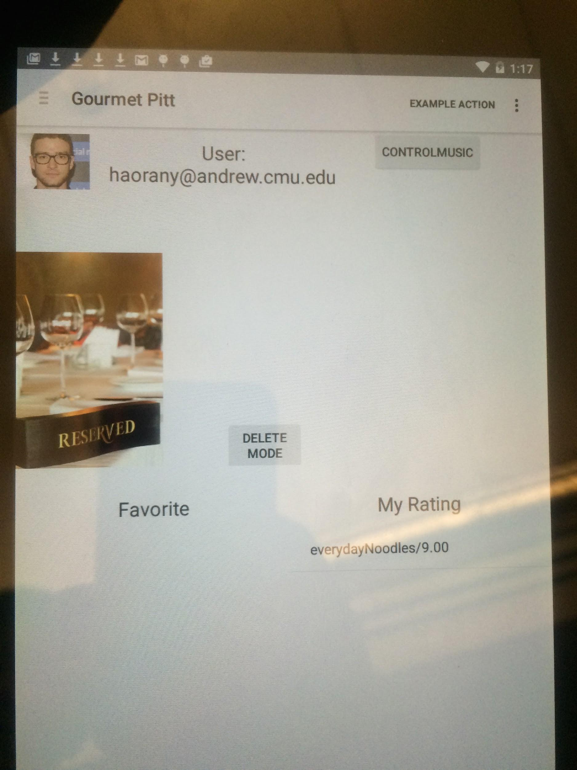

Main page is a welcome interface with the user’s portrait and a log out button and images of famous food in Pittsburgh.

Personal information holds all useful information with regard to the user.

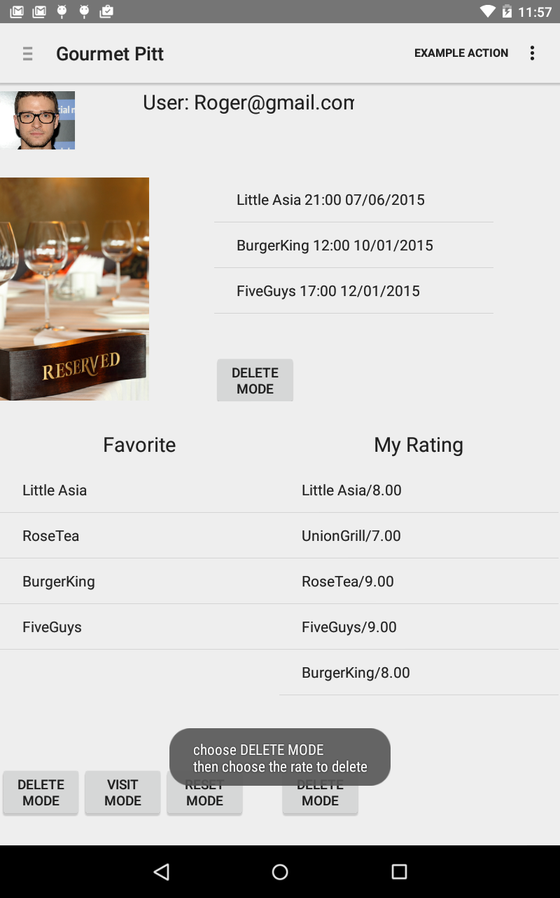

Customer’s portrait and registered email are shown on the top of the interface. To the right of the “reserved” image is the reservations made by the customer. A reservation can be added from the restaurant detail interface, which will be shown later. If a customer would like to delete a reservation, he/she should choose “delete mode”, then choose the reservation, then refresh the page by choosing “Personal Info” in the navigation bar, it can be seen that the reservation has been deleted.

The left division of the bottom is the customer’s favorite list. Prior to clicking on the restaurant names, the user should choose which mode, if a visit mode is chosen, upon clicking on a restaurant name, the user will be led to the restaurant’s page. If delete mode is selected, this favorite restaurant will be deleted from the customer’s favorite list.

The right division of the bottom is the rating records of the customer. By selecting the delete mode, the choosing a rating, the rating will be removed and the average rating of the corresponding restaurant will be recalculated.

The recommendation choice provides the customer with a list of all recommended restaurant links according to the customer’s flavor. The customer’s flavor was specified by the customer when registering himself/herself.

In the search interface, the customer can enter characters, while program will offer the restaurants whose name contains the characters. After provided with the restaurant list, the customer can filter the list by entering his conditions and the list will be updated instantly.

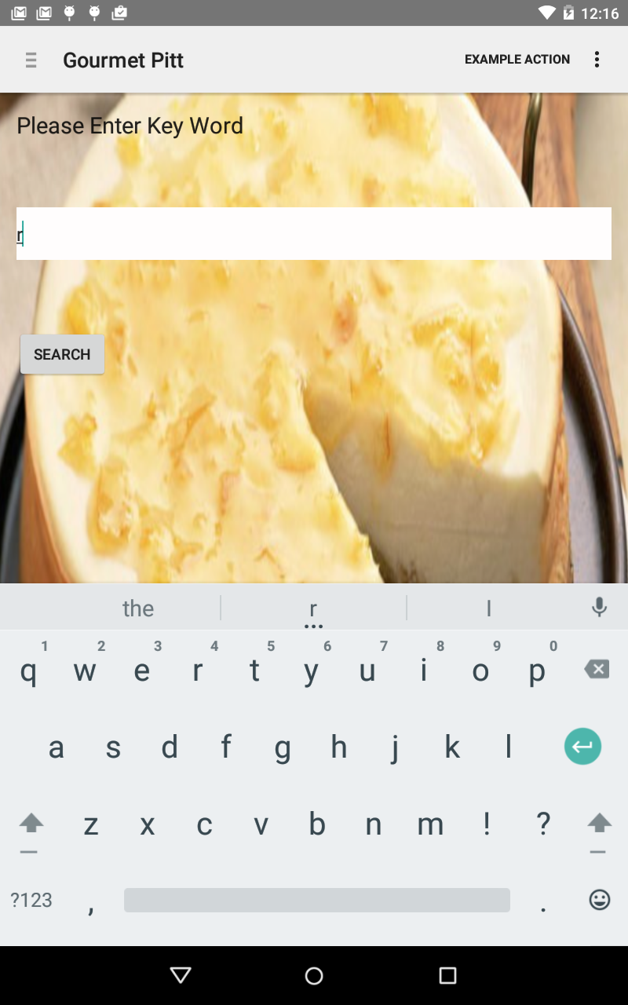

We also provide the voice recognization function. At the search page, if you click “Voice” button, you will enter a speaking catch window. What you have said will be caught as the key word to search restaurant.

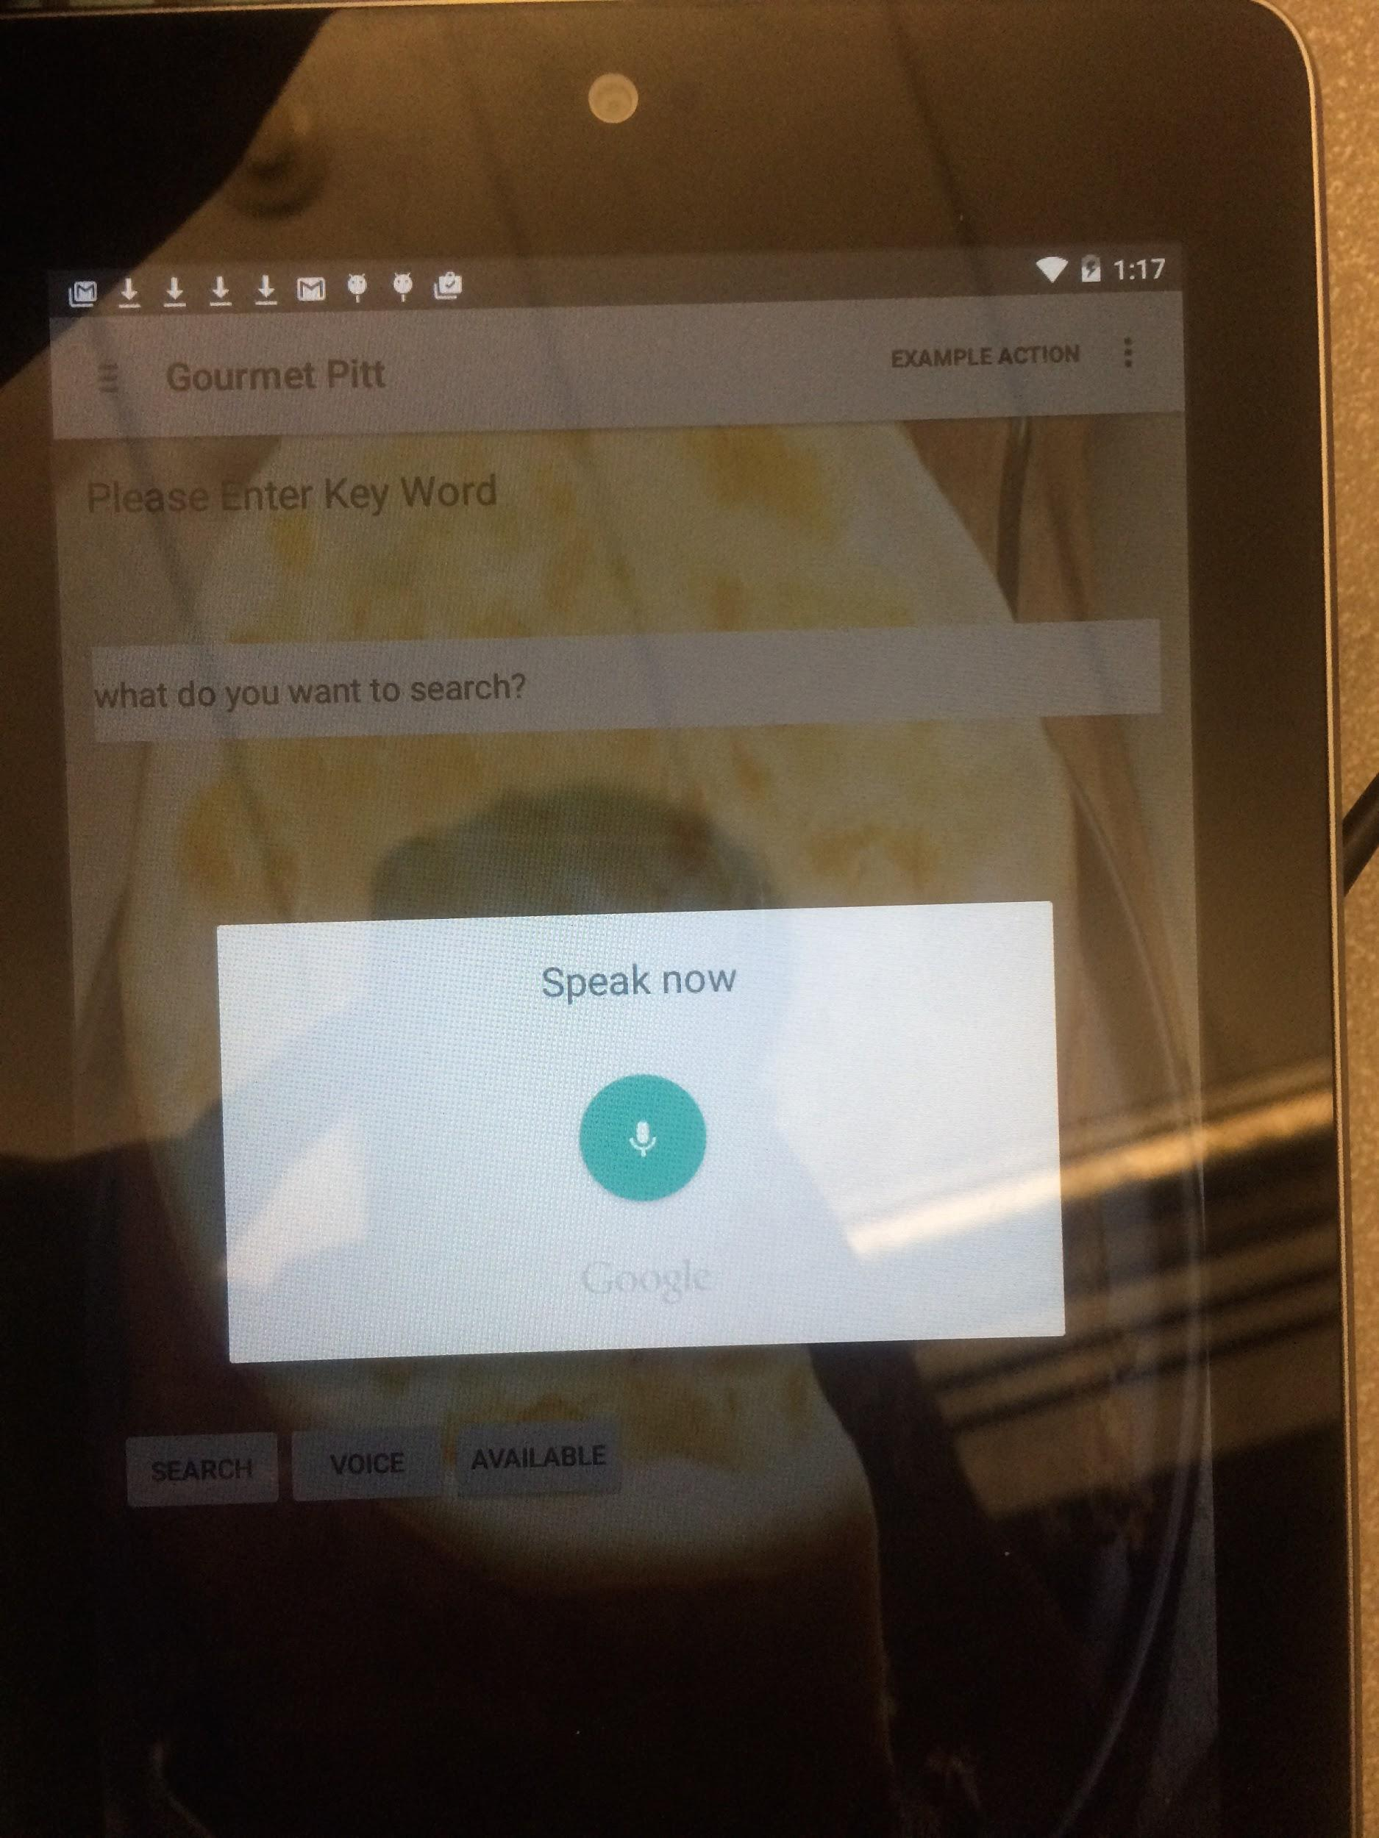

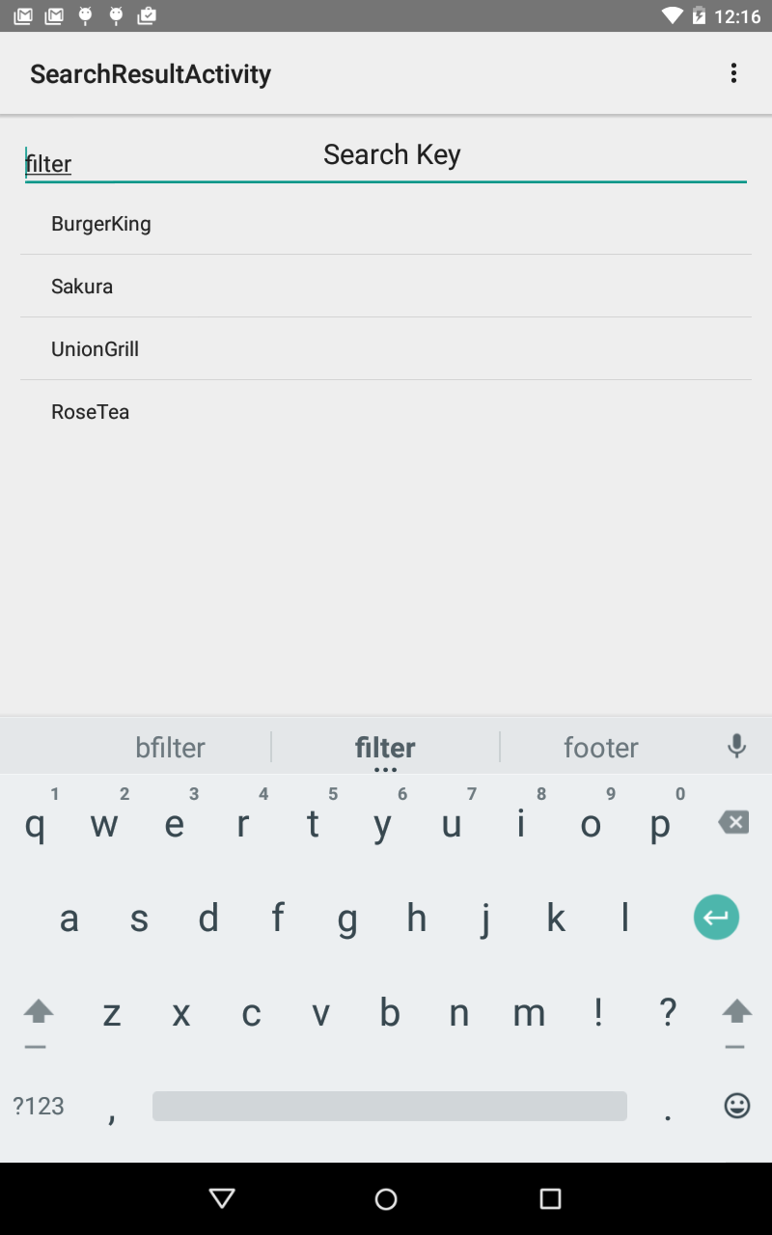

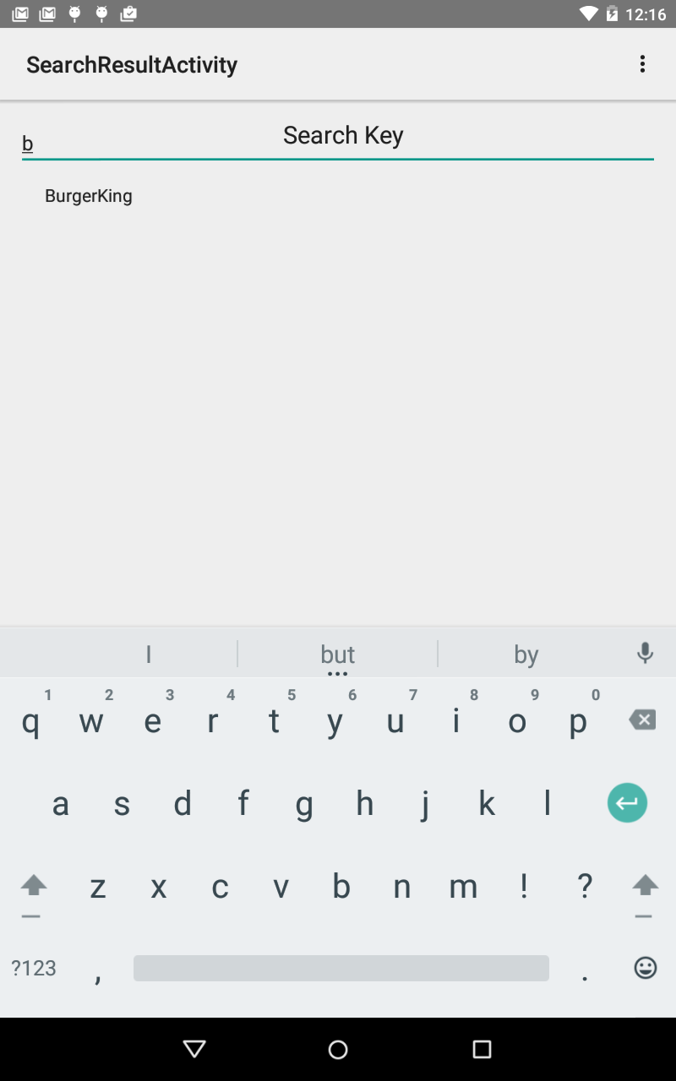

The restaurant detail interface offers all information and interaction with regard to a certain restaurant.

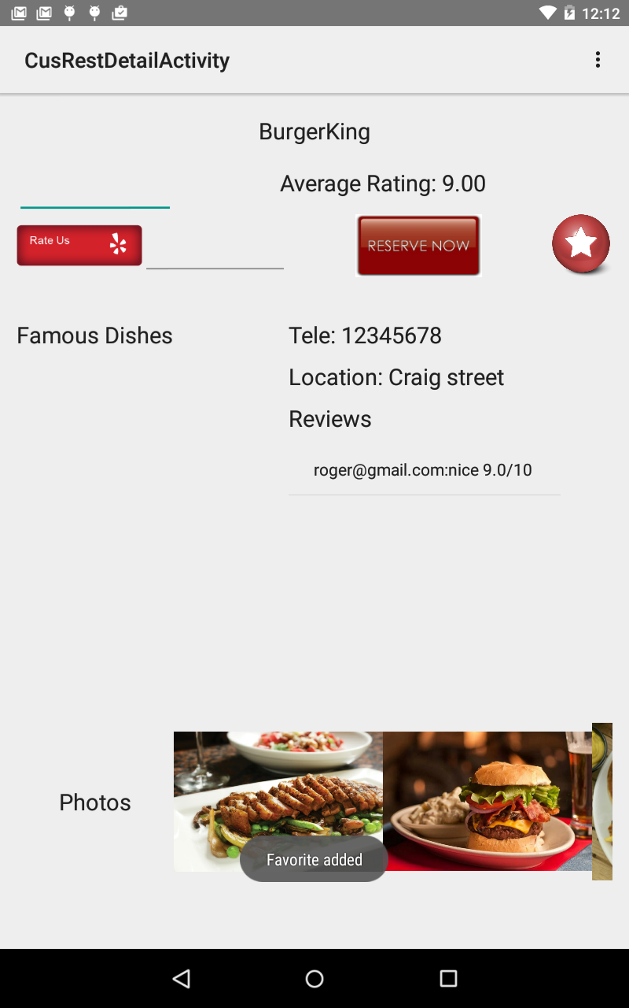

The restaurant name and average rating is printed on the top, below which there are three buttons. First is rate us, for customer to give review and rating for this restaurant. The above edit view is for review and the right edit view is for rating. By clicking on rate us button, the customer can add or update his/her rate/review for this restaurant and then the average rating will be recalculated.

By clicking on the reserve button, the customer will be navigated to the reservation interface.

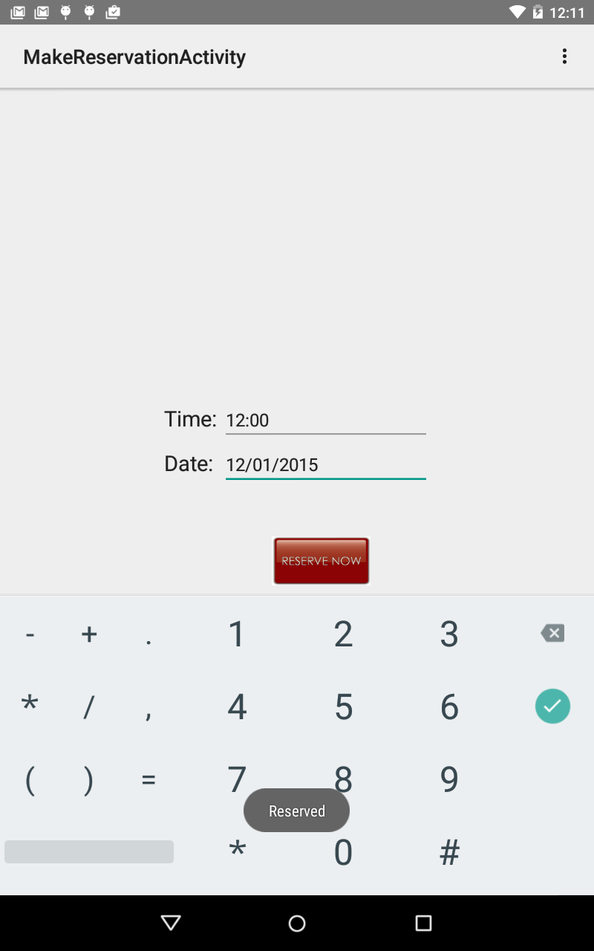

After entering the time and date of the reservation, by clicking on reserve now, the new reservation will be added to the customer’s reservation list.

The star button stands for add to favorite. By clicking on that, the customer can add this restaurant link to his/her favorite list.

Famous dishes offers a list of famous dishes, which are provided by the business owner. To the right of that is some detailed information such as telephone and address of this restaurant. And beneath that a list of customer rating and review is displayed.

At the bottom there is a scroll view of images of the dishes in the restaurant, uploaded by the business owner.

NearByRes function will help find your present location and list nearest restaurant due to your latitude and longitude. You can use map to see your location and see nearby restaurants directly.

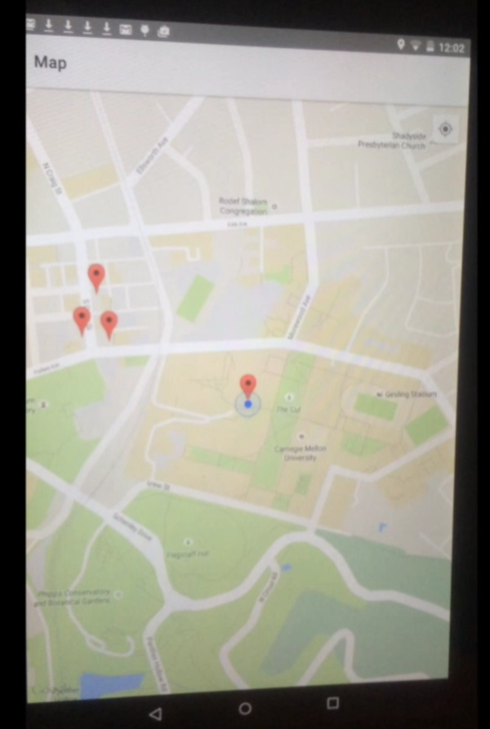

Business:

After a Business User successfully registered a valid account, he can log into his account by choosing “Login as Business”.

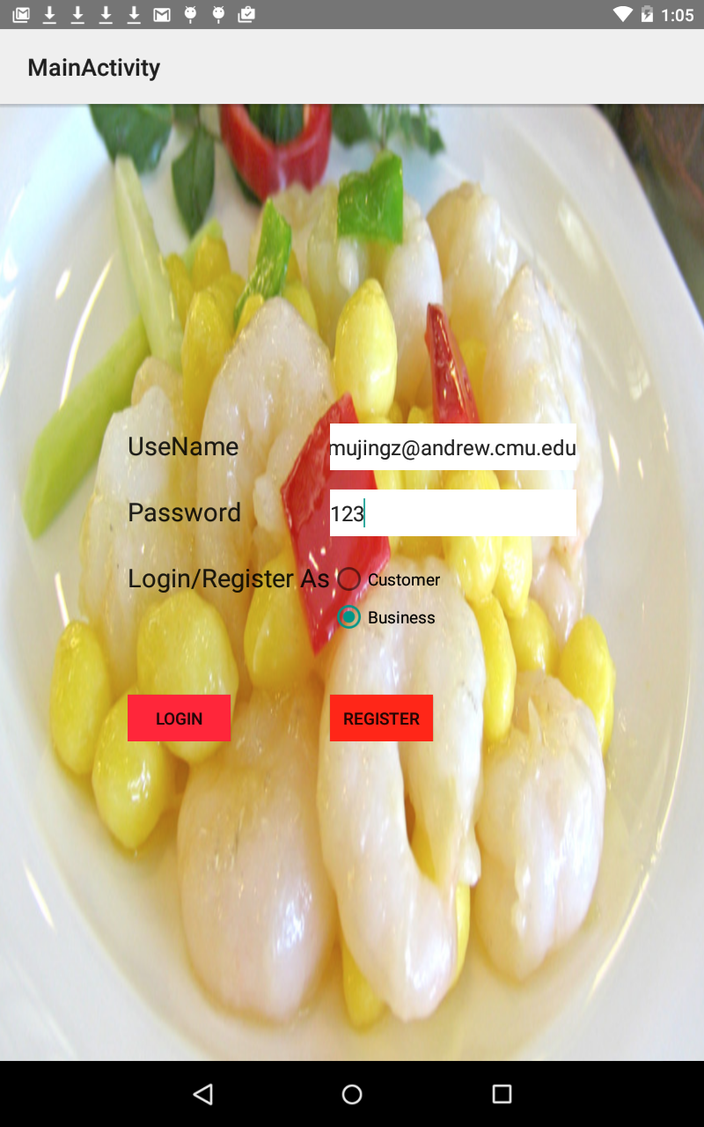

When Business user successfully logins into our application, the user can choose either “My Restaurant” or “Contact Us”. After choosing “My Restaurant”, he will be directed to the activity that displays all the restaurants that have already created.

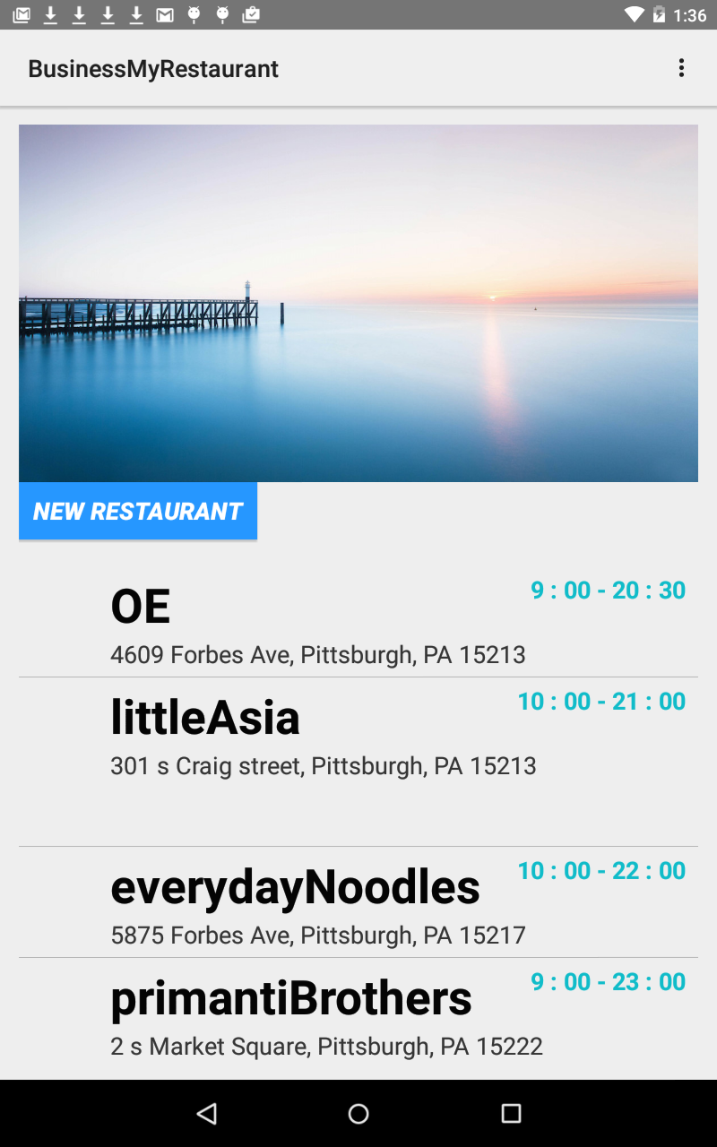

Also, on this page, Business user can choose to add a new restaurant under his account and will go to the page for entering needed information when creating a new restaurant.

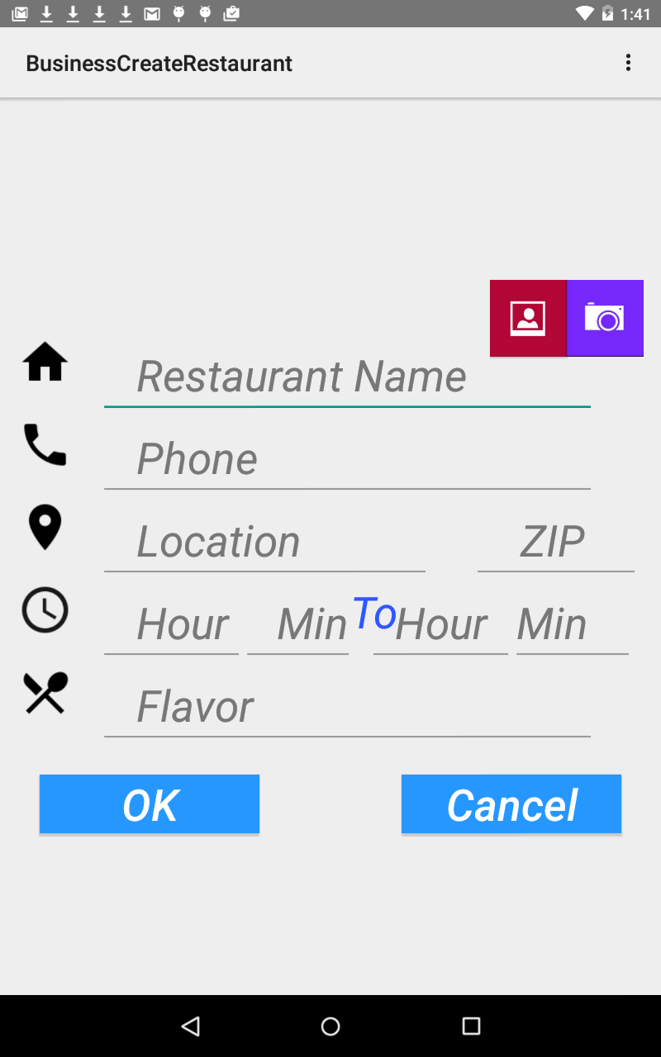

In this “new restaurant” page, the user can not leave these fields empty, otherwise exception will be prompted. The user can also choose to take a photo using the camera or upload photos from the gallery on the tablet. These uploaded photos will be used as the icon for these restaurants.

We use S3 (Simple Scalable Storage) of AWS to store pictures and photos on the cloud. Clicking a picture will make it uploaded automatically to bucket of S3. You can get pictures in the form as URL and store them in database conveniently.

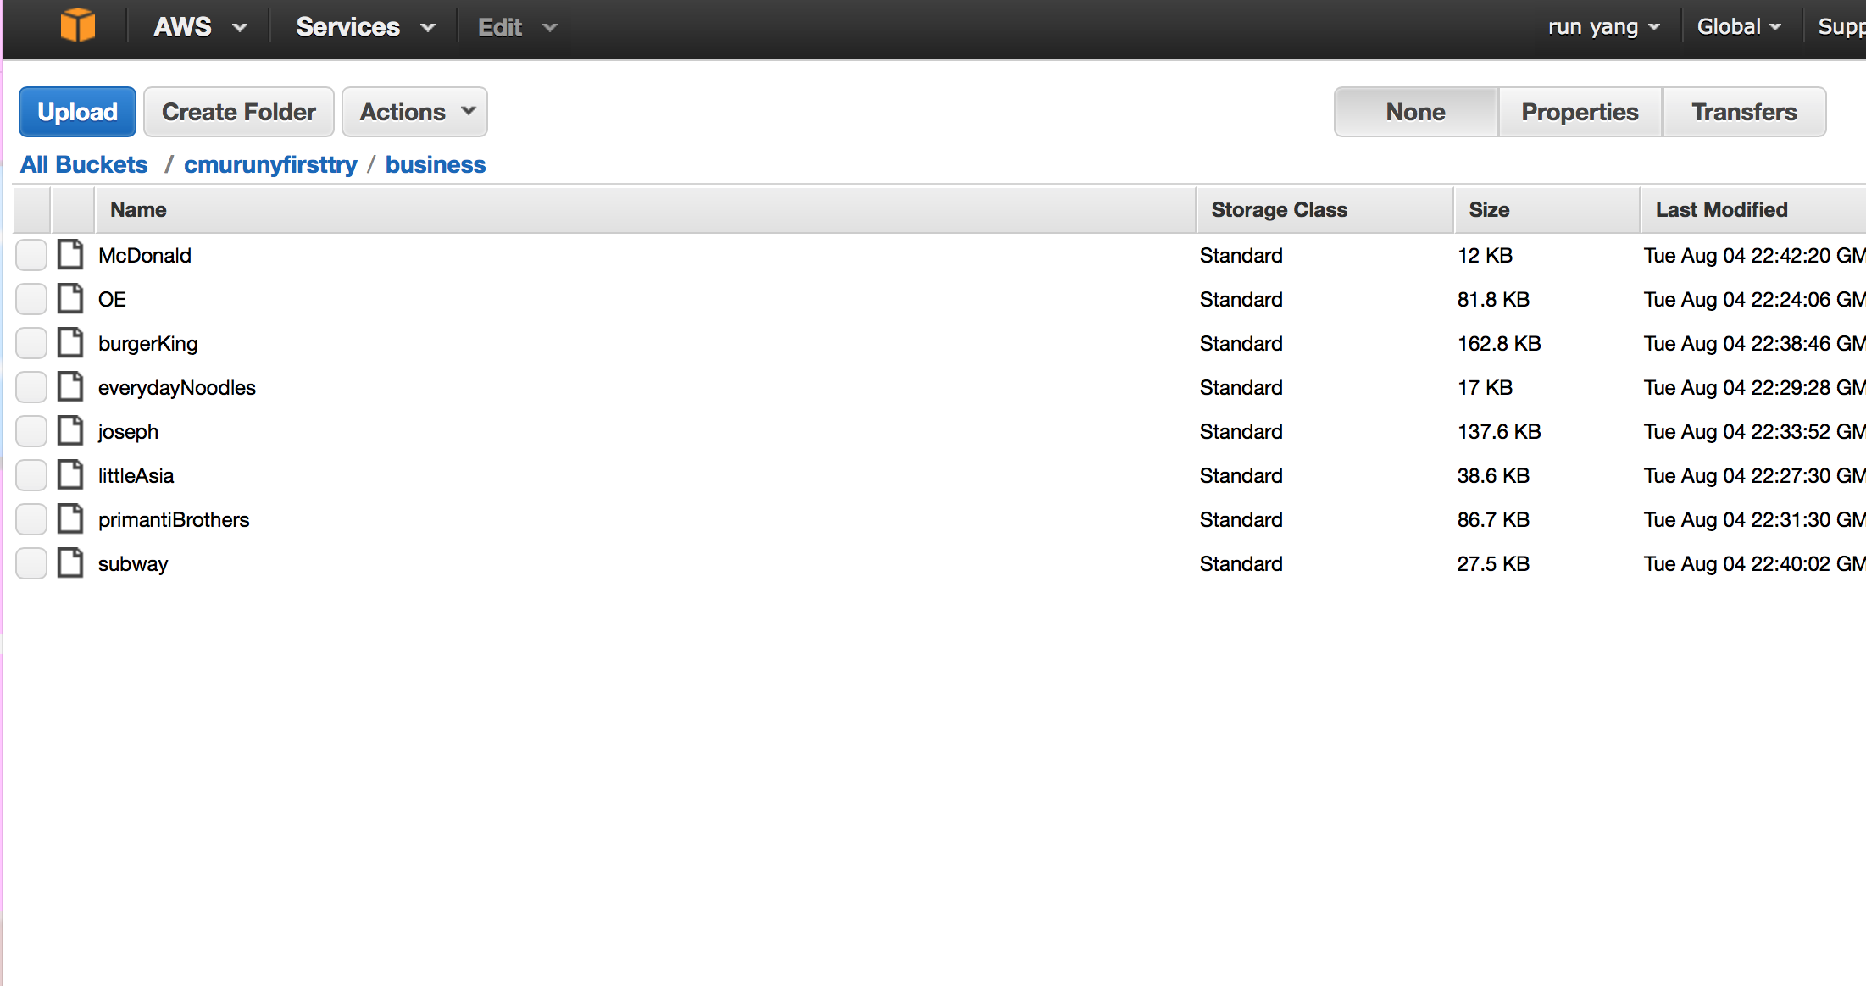

Also, on the “My restaurant” page, Business can choose to delete or edit an existing restaurant by swipe on the screen.

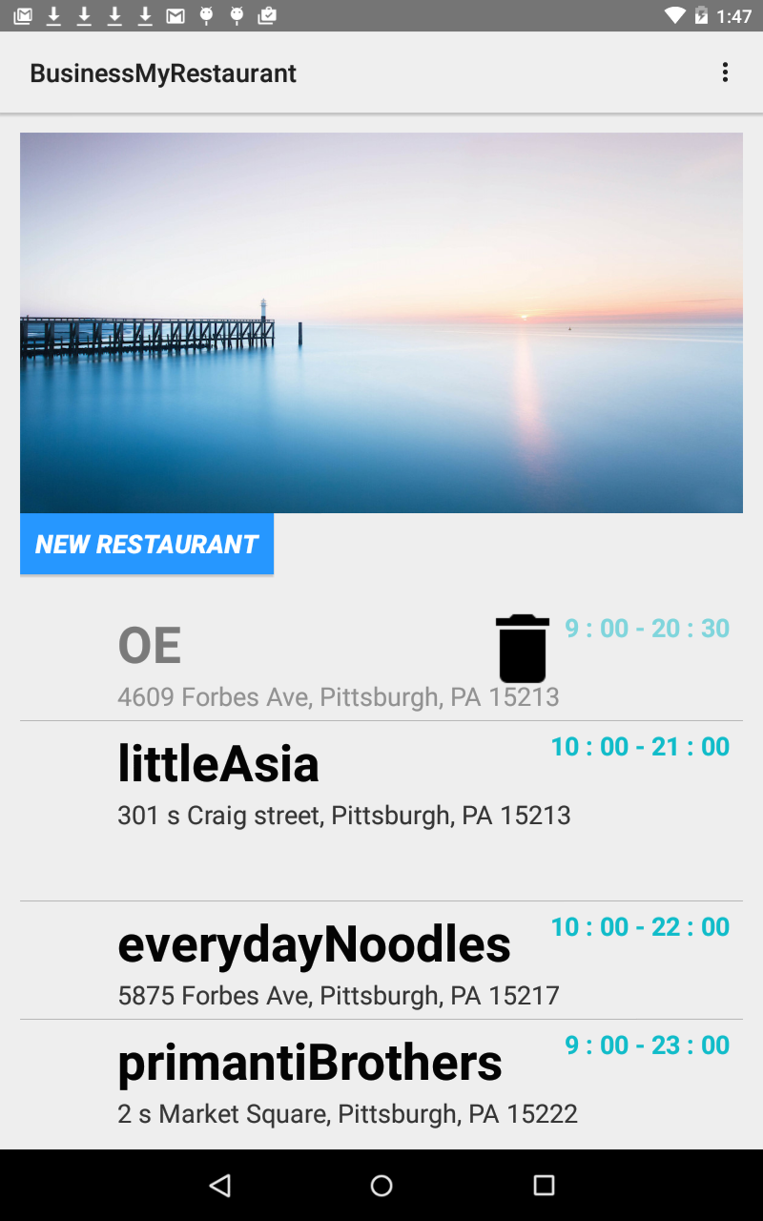

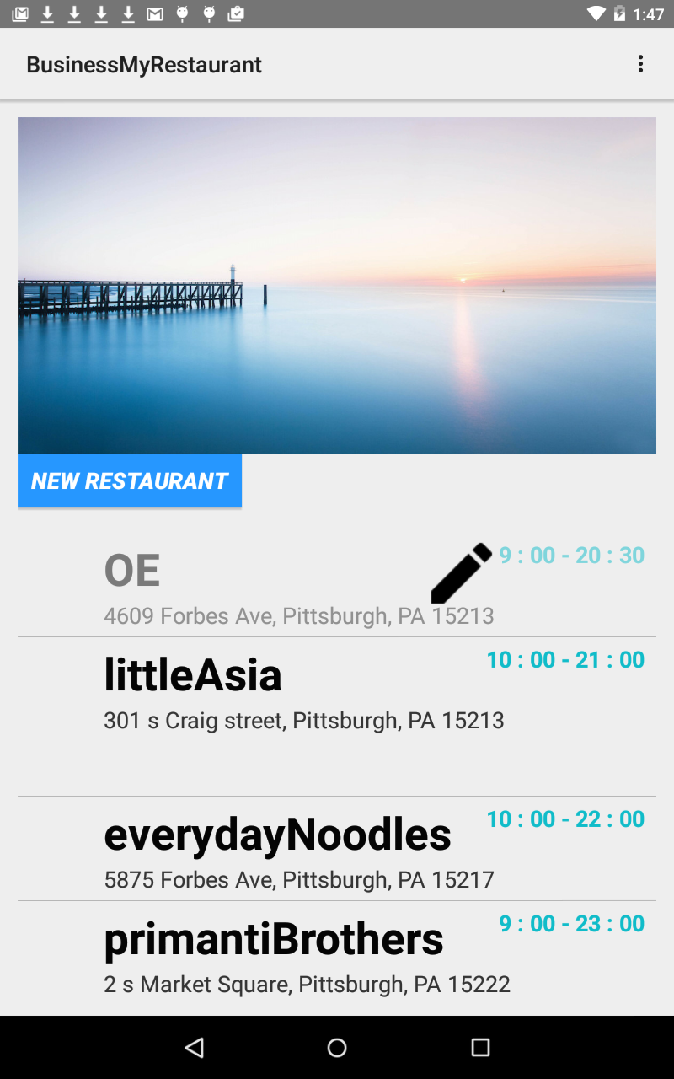

When choosing to edit an existing restaurant, Business will be directed to the page to edit information about the restaurant. Also, on this page, the user can choose to add dishes which will be shown to Customer users.

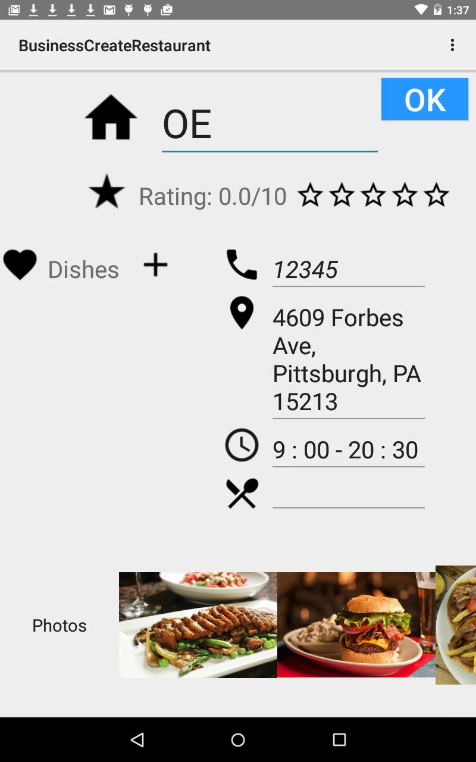

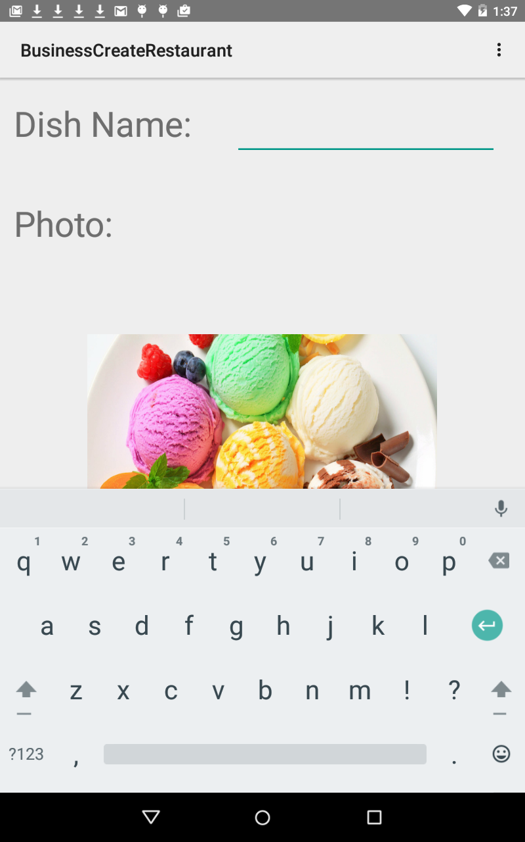

As mentioned above, on the Business home page, when Business user chooses to click on the “Contact Us”, the intent to launch the intent to send emails will be started so that the Business can edit feedback for developers.

